Assessment for Learning Strategies

The following ideas and resources are taken from current practice in our three schools: Bringhurst Primary, Hallaton Church of England Primary and Tugby Primary. They cover FS, KS1 and KS2.

Recapping the previous lesson’s outcomes:

- Involve all children by using e.g. talk partners
- Use examples of good work and ask children to explain their thinking
- Give children time to look at marked work from the previous lesson and to self or peer assess

Introducing the Learning Objective:

- use “I can” statements to provide a clear focus for the LO
- Differentiate LO and success criteria by group
- If work is to be recorded during the lesson, children either write their learning objective or have a sticker to show this in their book
- The format and number of LO’s will change according to children’s age and development e.g. for an English lesson: in Year 1 the LO is more likely to be conveyed to the children verbally whereas in Year 6 the children may have a written checklist of things to include in their writing.

Gaining feedback from children:

- The teacher models the use of the LO
- The teacher then questions and observes children to gain knowledge of children’s understanding of the LO
- From this information, the teacher adapts the lesson as needed and plans next steps in learning

Giving the success criteria:

- Introduce the SC with the children to develop their understanding of key points to remember throughout the lesson
- The SC is also written/shared verbally throughout the lesson
- Children are encouraged to use the SC during the lesson to self-assess and decide if they need support from e.g. an adult or another child

The role of the teacher during the main part of the lesson:

- Observing and providing feedback to groups and individuals
- Asking questions to develop children’s understanding. These should more often be open questions
- Asking children to reflect on their learning and to help them to continually improve their work – use the SC to guide these conversations

Using plenaries:

- Teachers use both mini-plenaries as needed during the main part of the lesson and a main plenary session at the end of the lesson
- Children are encouraged to both self and peer assess to deepen their understanding of the LO and SC
- Use the opportunity to show examples of successful work and to discuss improvements that can be made for next time e.g. use “three stars and a wish”, “next steps” or a “marking ladder”.
- Later after marking and considering the children’s work, the teacher decides how to feedback the outcomes and next steps to the children.

Appendices:

Examples of AfL (Y1)
WILF: I can use adjectives in my writing.

Next steps:

Simple self-assessment “sticker” for children’s writing books in Year 1

Tuesday | WALT: Describe a character and use “because” in a sentence. | WALT: Describe a character and a setting using adjectives. | WALT: Describe “good” and “bad” characters in traditional stories using interesting adjectives.
Stickers for children’s English books in Year 1, showing group differentiation of the LO.

Observations are more important at this age as much work is practical in nature. Observations are either planned/completed on a sheet such as this:
Foundation Stage Observation Form
Date:
Activity: | Area/s of learning: CL, PD, PSED, L, M, EaD, UW
Child/Children being observed: | Child’s/children’s stage of development (Early Years Outcomes):
Purpose of observation

Unplanned observations of the children are also done continually through photographs and notes on post-its. These observations are then used to plan the next steps in learning for individuals and groups.

Examples of AfL (Y6)

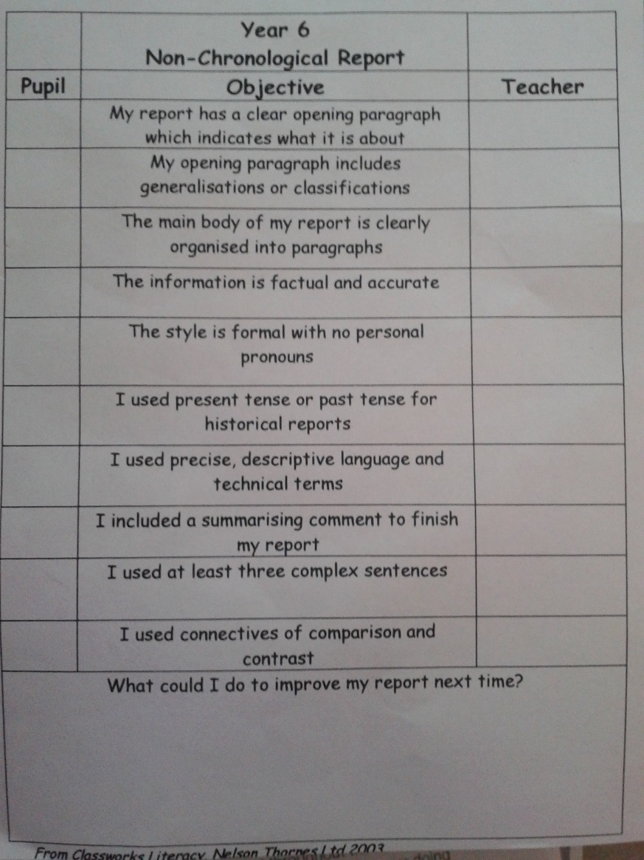

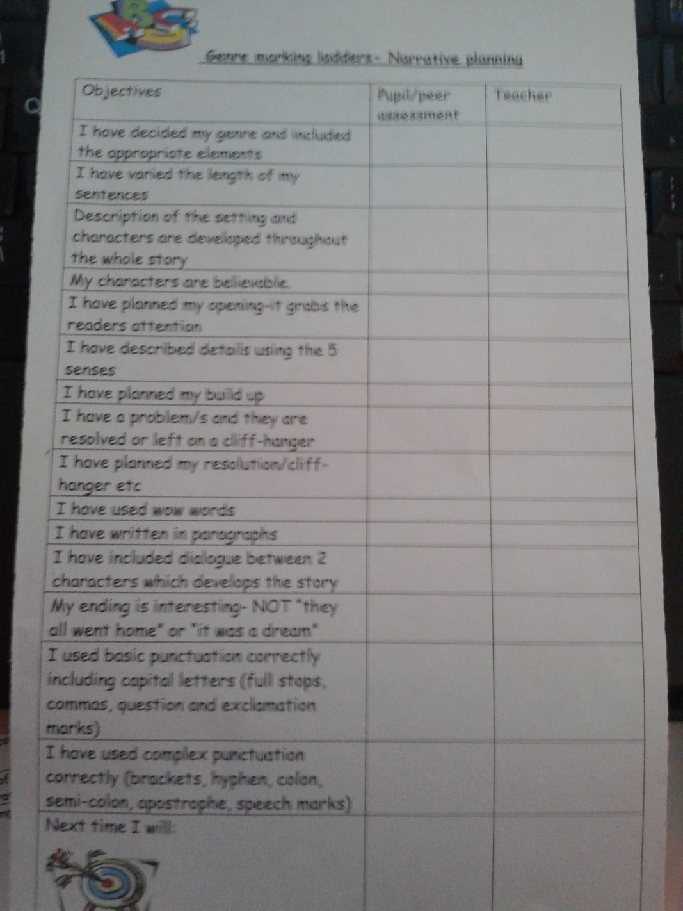

Examples of AfL using Bands:
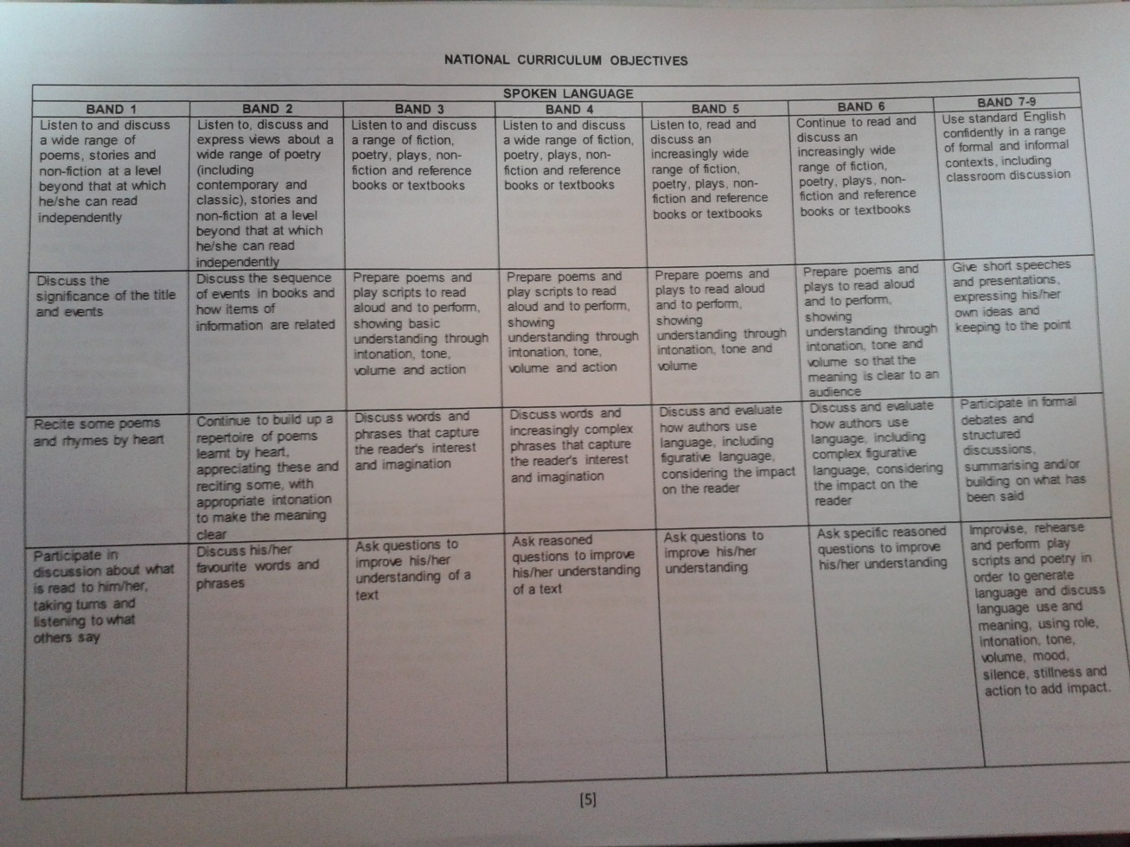
LO’s for English using Target Tracker

Examples of Success Criteria and Teacher/pupil Assessment
