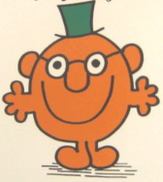
Helping myself and my classmates to improve

Present Tense | Future Tense | Connectives | Opinions | Reasons

Helping myself and my classmates to improve

Present Tense | Future Tense | Connectives | Opinions | Reasons

Helping myself and my classmates to improve

Present Tense | Future Tense | Connectives | Opinions | Reasons

